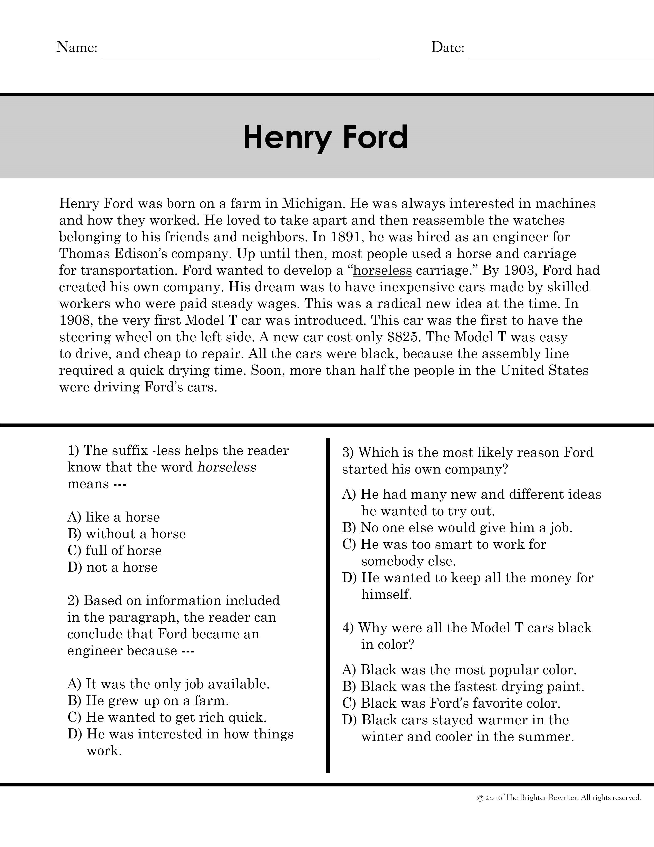

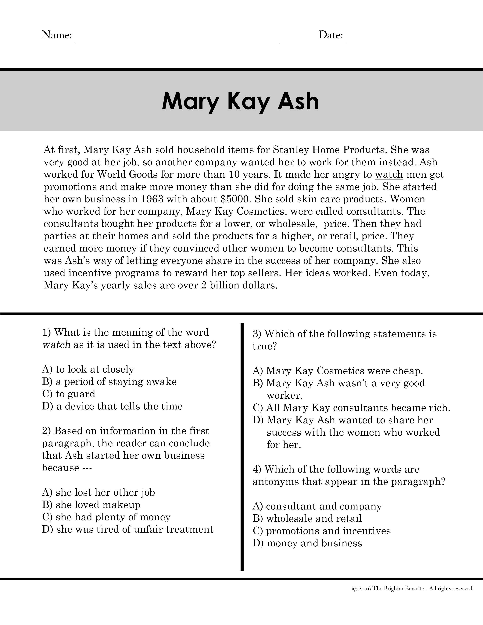



**Entrepreneurs Paragraphs Answer Key**

|  |  |  |  |  |
| --- | --- | --- | --- | --- |
| Henry  Ford | Mary Kay Ash | Wallace  Amos | Milton  Hershey | Sam  Walton |
| 1. B 2. D 3. A 4. B | 1. A 2. D 3. D 4. B | 1. D 2. C 3. A 4. C | 1. B 2. C 3. D 4. A | 1. D 2. C 3. D 4. C |

© 2016 The Brighter Rewriter. All rights reserved.